|  |  |
| --- | --- |
| EGC_Black | Student Name \_\_\_\_\_\_\_\_\_\_\_\_\_\_\_\_\_\_\_\_\_\_\_    **Eastern Goldfields College**  Mathematics Applications 2017  Test 5 (U2 T2) – Calculator Free1 |
|  | **Total Marks: 27 marks** |

**Time allowed: 25 minutes**

**No calculator or notes permitted for this section.**

***Answer all of the following questions. Show all working to obtain full marks.***

**Question 1** **(5 marks: 1, 2, 2)**

State the **gradient** and the **co-ordinates** of the **y intercept** of each of the following straight lines.











$y=4-5x$

$3y=6x-2$

$2x+2y=10$

**Question 2** **(4 marks: 2, 2)**

In the diagram below, Point **B** is at a true bearing of 075o from point **A**.

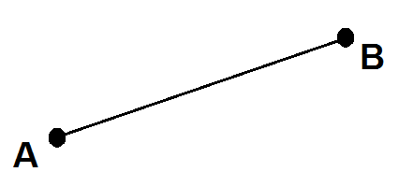

1. What is the compass bearing **from** A **to** B? \_\_\_\_\_\_\_\_\_\_\_\_\_\_\_\_\_\_\_\_\_\_\_
2. What is the true bearing **to** A **from** B? \_\_\_\_\_\_\_\_\_\_\_\_\_\_\_\_\_\_\_\_\_\_\_

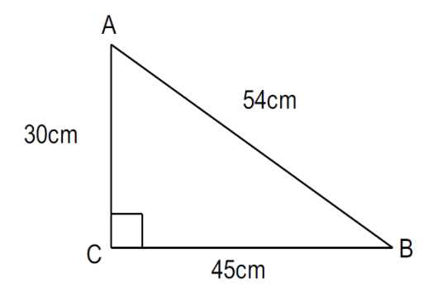**Question 3**  **(2 marks: 1, 1)**

Consider the triangle *ABC*.

a) Determine the value of 𝑠𝑖𝑛 ∠ 𝐵𝐴𝐶.

b) If the lengths of the sides of the triangle were all doubled in size, how would this effect the value of 𝑠𝑖𝑛∠ 𝐵𝐴𝐶?

**Question 4** **(5 marks: 2, 3)**

Harry was 15m due south of Zayn. Liam is due east of Harry and on a bearing of 158° from Zayn.

1. Draw a diagram to represent the above information.

1. Calculate the distance between Harry and Liam. **Hint:** *tan22 = 0.4 (approximately)*

**Question 5** **(11 marks: 1, 2, 1, 2, 2, 1, 2)**

The Brown Taxi company charge a flag fall of $3 and a rate of $2 per kilometre travelled.

They use the formula: *F* = 3 + 2*d*, where *d* is the distance travelled in kilometres, to calculate the fare charged *F* (in dollars). For example, a taxi ride of 5 km would cost $13.

(a) Matthew took a Brown Taxi from Perth to his home, a distance of 25 km. Calculate the

fare Matthew was charged.

(b) Peta is charged $41 for catching a Brown Taxi home. What distance did she travel in the

taxi?

The Orange Taxi company charge a flag fall of $6 and $1.50 per kilometre travelled.

(c) Write a formula for the fare charged by the Orange Taxi company in terms of *d* (the

distance travelled).

*F* =

(d) Madeline is deciding whether to catch a Brown Taxi or Orange Taxi to her home. She

wants to choose the cheaper company. She needs to travel 10 km. Which company

should she choose? Justify your answer with calculations.

(e) Brown taxi company has been plotted below. Add Orange taxi company charges to the graph

below.

(f) Determine the distance travelled that will result in the fares for the Orange and Brown

Taxis being equal.

(g) Emily wants to give her mother some advice about which taxi company to choose so that her

fare is always the cheapest. What advice should Emily give her mother?

**End of Non-Calculator Section**

|  |  |
| --- | --- |
| EGC_Black | Student Name \_\_\_\_\_\_\_\_\_\_\_\_\_\_\_\_\_\_\_\_\_\_\_    **Eastern Goldfields College**  Mathematics Applications 2017  Test 5 (U2 T2) – Calculator Assumed1 |
|  | **Total Marks: 32 marks** |

**Time allowed: 35 minutes**

**Calculator and 1 x double sided A4 notes permitted for this section.**

***Answer all of the following questions. Show all working to obtain full marks.***

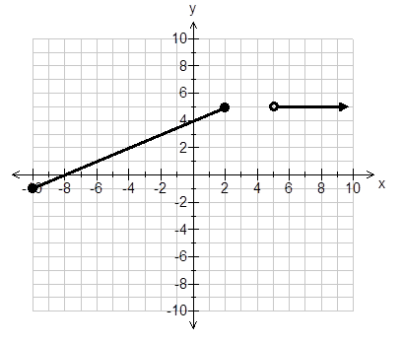**Question 1** **(8 marks: 2, 2, 4)**

Consider the piecewise function shown.

1. For what values of 𝑥 is 𝑦 = 5?
2. Label each of the gradients for each

section of this graph.

1. Write functions to define the graph   
   shown.

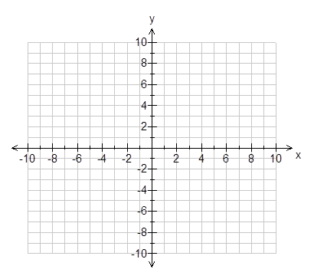

**Question 2** **(5 marks: 3, 2)**

Graph the following functions on the

axes.



$y= -x+1; -7<x<5$

$x=10; y≥-5$

**Question 3** **(5 marks: 3, 2)**

Aimee and Claire are playing hide and seek with Sam in the park. Sam will be seeking. Aimee

leaves Sam on a bearing of 116 degrees and goes 23m to hide. Claire leaves Sam and goes

35m on a compass bearing of South 12O East to hide. Claire and Aimee’s hiding spots are 19m apart.

1. Draw a diagram of this situation
2. What bearing does Claire have to take to return back to Sam?

**Question 4** **(3 marks)**

Calculate the value of the unknown side in the following right-angled triangle. Round your answer to 1 decimal place.

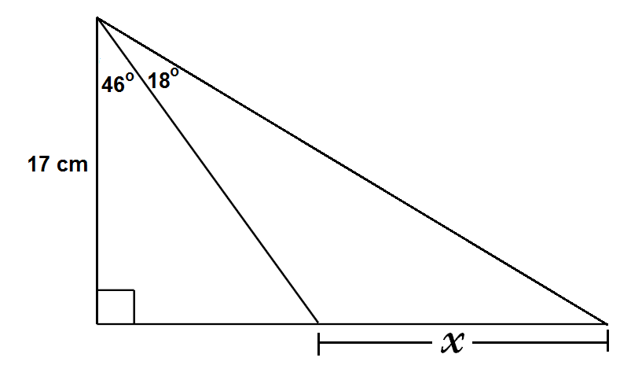

**Question 5** **(4 marks: 2, 2)**

The diagram below shows an area of forest bounded by roads JKL, JN and NML. It is known

that JK = 632 m, KL = 1120 m, NL = 1912 m and that angles LJN and LKM are both 90°.

**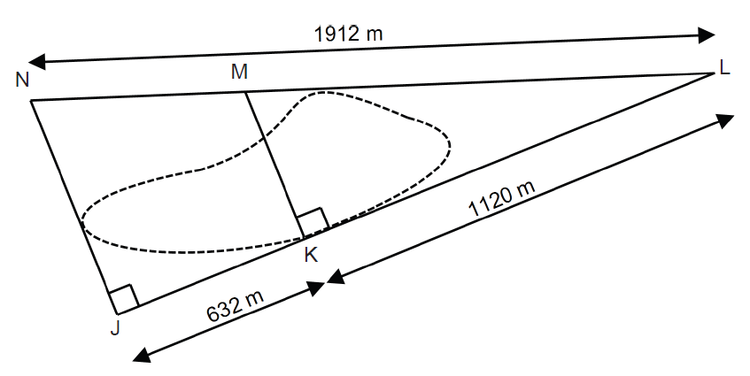**

(a) Determine the length of road JN. Round your answer to the nearest metre.

(b) Determine the size of angle JLN. Round your answer to the nearest integer.

**Question 6** **(7 marks: 1, 2, 1, 3)**

A children’s slide at the park can have a maximum angle of elevation of 31 degrees according to council regulations.

A 2.5m slide is erected in a park with the maximum slope.

a) Draw a diagram of this slide.

b) Determine the height of the slide. Round your answer to 1 decimal place.

The playground engineer wants to make a second slide. He wants it to be 1.3m high and 2.2m long.

1. Draw a diagram of this slide.

d) Does this second slide pass council regulations? Justify.

**End of Calculator Section**